Example Report
Dr Jon Kragskow

Introduction
This report shows the ease with which correctly sized Matplotlib figures can be included in Microsoft Word.
Results and Discussion
We have considered the following first order, elementary, reaction
$$A\underset{→}{k}B$$
The time-dependence of the concentration of species $A$ can be described by the first-order integrated rate equation
$${\left[A\right]}_{t}={\left[A\right]}_{0}\exp{(-kt)} .$$
We have simulated the time-dependence of $[A]$ using an initial concentration of $1 mol {dm}^{-3}$, and two different values of the rate constant, $k=1 s^{-1}$ and $k=5 s^{-1}$ (Figure 1).
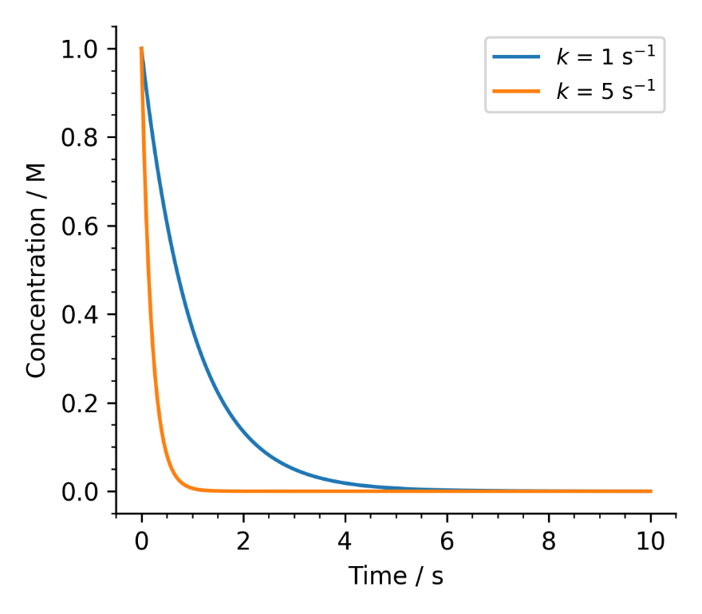
Figure 1: Simulated concentration of $A$ as a function of time according to a first-order model. The model uses an initial concentration of $1 mol {dm}^{-3}$ and a rate constant of either $1 s^{-1}$ (blue) or $5 s^{-1}$ (orange).
Conclusions
With only a little bit of effort, you too can make amazing plots.

